Factors affecting chemical equilibrium.

* Equilibrium in chemical reactions is affected by several factors. Since equilibrium is achieved when the rate of the forward reaction equals the rate of the reverse reaction, any factor that can change these rates will affect equilibrium.
* One factor that affects equilibrium is concentration of reactants and products. By increasing or decreasing the concentration of any of the substances involved, the equilibrium position will change.
* Another factor that affects [dynamic equilibrium](http://socratic.org/chemistry/phases-of-matter/dynamic-equilibrium-of-phase-changes) is temperature. Depending on if the reaction is *exothermic* or *endothermic*, the shift will be toward the reactants or toward the products.
* If gases are involved in the reaction, another factor that affects [dynamic equilibrium](http://socratic.org/chemistry/chemical-equilibrium/dynamic-equilibrium), is pressure.
* To begin, we need to understand what equilibrium position is and state Le Chatelier’s principle.

Equilibrium position

* The equilibrium position of a reversible reaction is a measure of the concentrations of the reacting substances at equilibrium.

For example

* Nitrogen gas is reacted with hydrogen gas to make ammonia gas.

N2 (g) + 3H2 (g) ⇌ 2NH3 (g)

* The equilibrium position is:
  + to the left if the concentrations of N2 and H2 are greater than the concentration of NH3 (more Nitrogen and hydrogen gas is produced)
  + to the right if the concentration of NH3 is greater than the concentrations of N2 and H2 (more ammonia gas is produced)

Le Chatelier’s Principle

* A scientist named Le Chatelier came up with a principle that will help us predict how these factors we mentioned can affect the position of the equilibrium.
* ***Le Chatelier’s principle states that if a system at equilibrium is subjected to any change, the system will adjust itself to oppose the applied change.***
* For example, if the temperature is increased, the position of equilibrium moves in the endothermic direction to reduce the temperature.

Effect of changing pressure.

Pressure only affects equilibrium in reactions involving gases.

Pressure is caused by collision of the gas particles with the walls of the reaction vessel. The more the number of molecules present, the higher the number of collisions and hence the higher the pressure.

If the pressure of a gaseous reaction mixture is changed the equilibrium will shift to oppose that change (Le Chatelier’s principle).

Experiment to illustrate effect of change in pressure

The effect of changing pressure can be illustrated using the equilibrium established between nitrogen (IV) oxide and dinitrogen tetra oxide

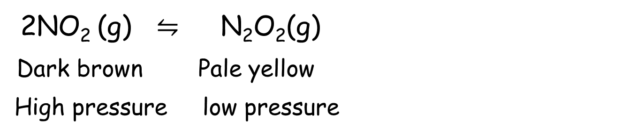

Consider what happens when the two gases are enclosed in a syringe.

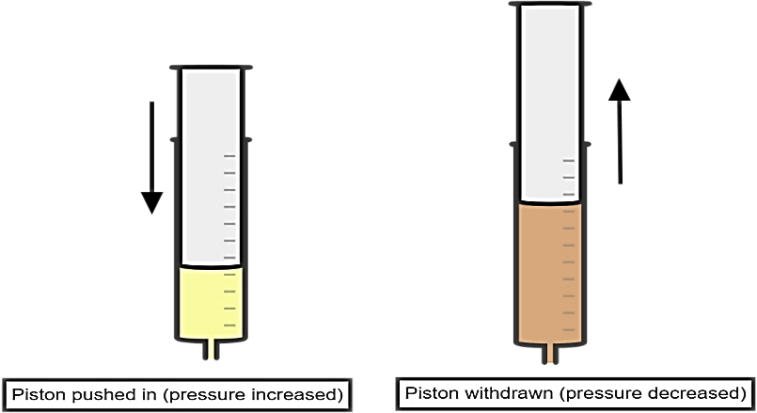

* When the piston is pushed in, the volume of the gases is reduced hence increasing the pressure. The content of the syringe appear *pale yellow*.
* This shows that *an increase in pressure favours the forward reaction which forms fewer molecules* *(1 molecule of N2O2 in the right hand side)*.
* When the piston is withdrawn slowly, the contents of the syringe *darken* as the volume increased therefore lowering the pressure.
* This shows that *reverse reaction which forms more molecules is favoured by lowering the pressure*. *(2 molecules of NO2 in the left hand side of the equation)*.

Conclusion

* If the pressure is increased the equilibrium will shift to favour the direction that has fewer molecules (lowers the pressure)
* If the pressure is decreased the equilibrium will shift to favour the direction that has more molecules. (increases the pressure)

Example 1

Consider the following reaction involving gases.

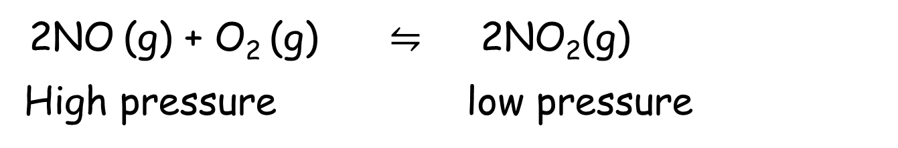

The left-hand side has higher pressure *(2+1=3 molecules)* than the right side *(2 molecules)*.

Applying pressure will favour the forward reaction since it reduces the pressure. A decrease in pressure favours the direction of reaction that forms more molecules.

Example 2.

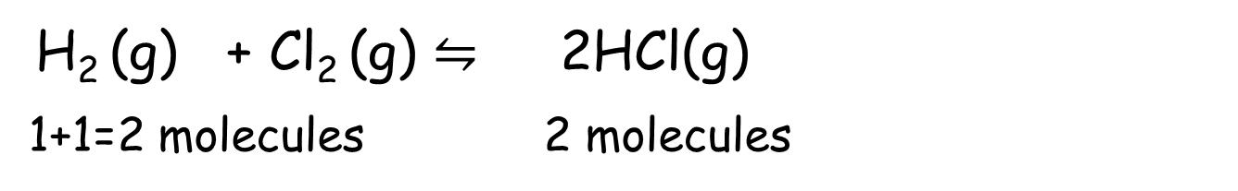

If the *number of molecules of reactants equals number of molecules of products*, a change in pressure does not have any effect on the equilibrium.

Change in pressure will not affect the position of equilibrium but will help in the quick attainment of the equilibrium.

Test yourself

Sulphur (IV) oxide reacts with oxygen to make sulphur trioxide in a reversible reaction:

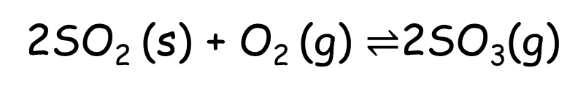

Predict the effect of increasing the pressure

Effect of changing the temperature

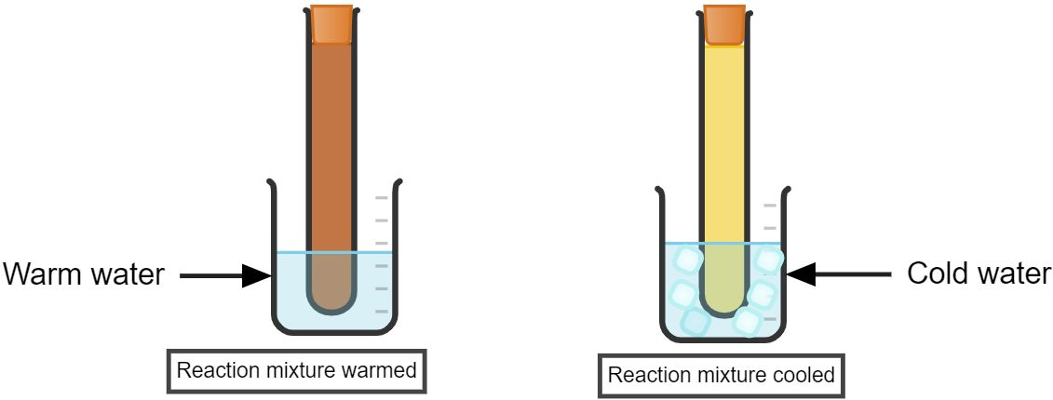

Procedure

1. Prepare nitrogen (IV) oxide by reacting copper turnings with concentrated nitric (V) acid.
2. Collect the gas produced in a test-tube fitted with a lid.
3. Cork the test-tube when it is filled with the gas. Warm the test-tube and observe any colour changes.
4. Now cool the test-tube in ice-cold water and record any colour changes.

Discussion and results

* When the mixture is heated, the dinitrogen tetraoxide molecules break up to form nitrogen (IV) oxide molecules. The mixture changes to brown colour.

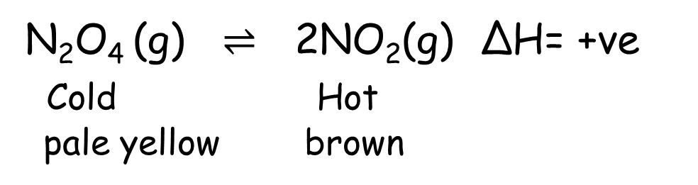

* The forward reaction in the equation is endothermic since rising the temperature will favour the process that absorbs heat. In this case the equilibrium shifts from left to right and that is why the mixture *becomes dark-brown*.
* A decrease in temperature favours the reaction which liberates heat. Since reverse reaction is exothermic, the colour of the mixture *becomes pale-yellow*.

Conclusion

In a reversible reaction, if the reaction is exothermic in one direction, it is endothermic in the other direction.

According to Le Chatelier’s principle, if the temperature of a reaction mixture is changed, the equilibrium will shift to oppose that change.

* If the temperature is increased the equilibrium will shift to favour the reaction which will reduce the temperature. The endothermic reaction is favoured.
* If the temperature is decreased the equilibrium will shift to favour the reaction which will increase the temperature. The exothermic reaction is favoured.

Example 1

The equation below shows the equation for the production of hydrogen in Haber process. What is the effect of increasing temperature?

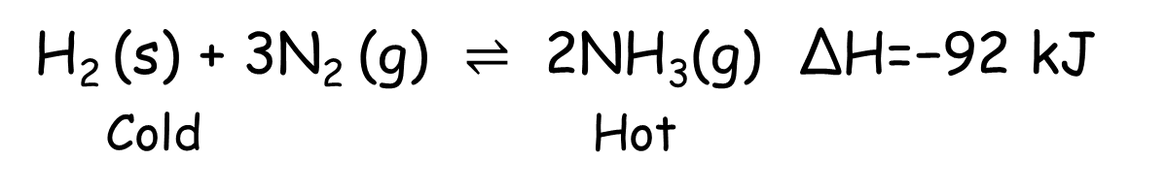

* If the forward reaction is exothermic, the backward reaction must be endothermic.
* Therefore, if the temperature is increased, the equilibrium position moves in the endothermic direction (to the left) to reduce the temperature. This means that less ammonia (NH3) will be produced.

Test yourself

Hydrogen can be manufactured by reacting carbon with steam:

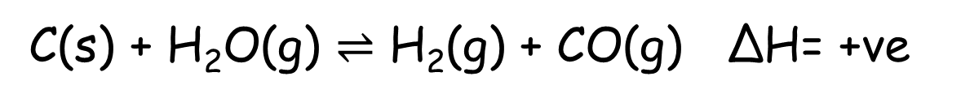

Predict the effect of increasing the temperature.

### Effect of change in concentration on equilibrium

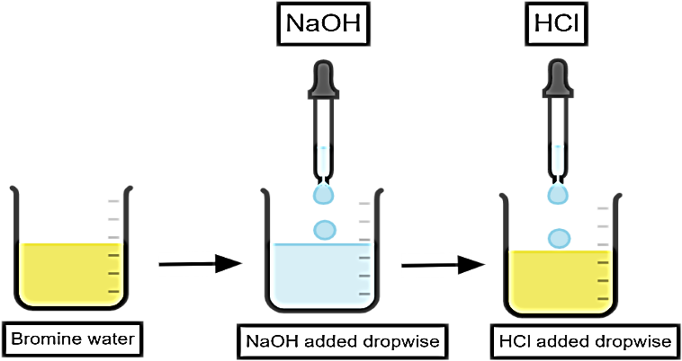

Procedure

1. Place 20cm3 of bromine water in 100cm3 beaker.
2. Using a teat pipette add 2M sodium hydroxide solution into the beaker drop wise while shaking. Continue adding until there is no further visible change in colour. Record your observation.
3. Add 2M Hydrochloric acid solution into the mixture dropwise while shaking until in excess. Record your observation.

Discussion and results

Bromine water is be prepared by dissolving two drops of liquid bromine in a litre of water. The mixture is allowed to settle to attain equilibrium. The solution is yellow in colour.

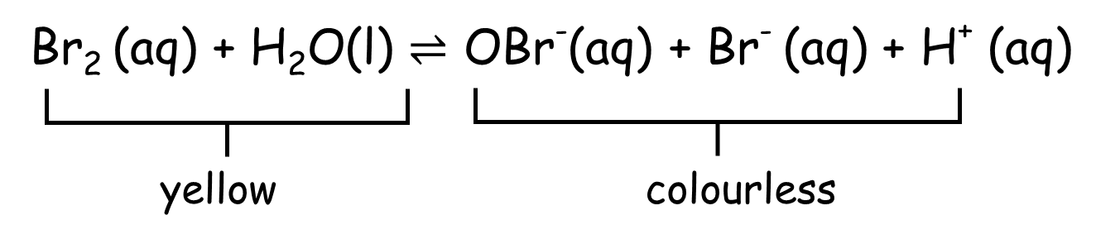

* The presence of bromine molecules makes the solution *yellow*.
* Adding sodium hydroxide (NaOH) will affect the position of the equilibrium. While neither sodium ions (Na+) nor hydroxide ions (OH-) are present on either side, the *hydroxide ions will react with H+ ions to form water*.

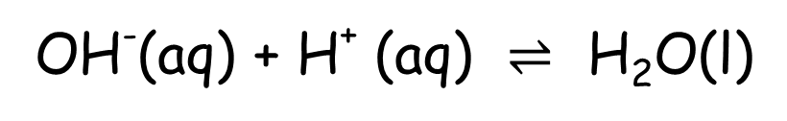

* The equilibrium will shift to the right hand side to replace the hydrogen ions that were removed. Thus the solution *turns colourless*.
* If hydrochloric acid was added to the equilibrium mixture, both hydrogen ions (H+) and chloride ions (Cl-) are being added.
* Hydrogen ions are on the right hand side of the equilibrium, therefore the equilibrium will shift to the left hand side to compensate, resulting in a higher concentration of reactants. This increases the *intensity of the yellow colour*.

Conclusion

* If the concentration of a reactant (on the left) is increased, the equilibrium position moves in the direction away from this reactant, and so more of the products are produced (on the right).
* If one of the products is removed from a reaction (on the right), then the position of equilibrium moves to the right to make more of that product.